Lab 6: Blood Pressure

ISIM Fall 2019

Lilo Heinrich

**Circuit**

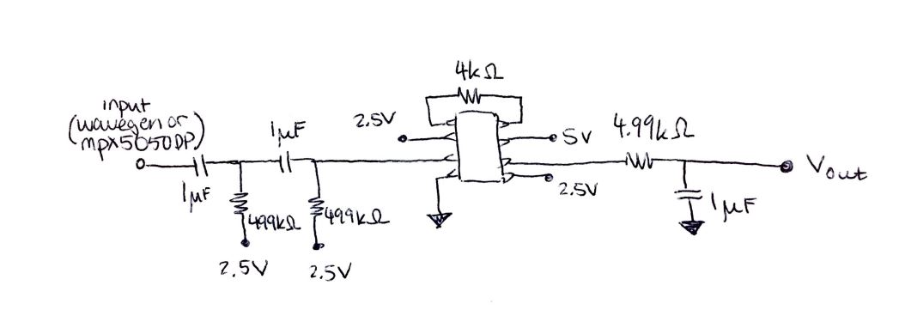

CR High Pass Second order filter values:

C = 1 µF, R = 499 kΩ

Cutoff frequency (calculated as 1/(2πRC)): 0.3 Hz

Chosen because around 0.2 Hz is the slow decay frequency, so it was convenient and close to this value.

RC Low Pass First order filter values:

C = 1 µF, R = 49.9 kΩ

Cutoff frequency (calculated as 1/(2πRC)): 3.2 Hz

Chosen because maximum reasonable heart rate is around 180 bpm, or 3 Hz.

Rg (Gain of Amplification) value for the AD623 instrument amplification chip:

G = 1 + 100 kΩ / Rg, where Rg = 4 kΩ

The recommended gain was 25, so working backwards, a convenient value for Rg is 4 kΩ.

The resistors on the two high-pass filters are connected to 2.5 V to create an offset from 0 V so that their output is centered around this offset and will not become negative. If the voltage becomes negative, the amplifying chip will be unable to amplify this signal due to negative voltage being outside of its’ range.

**Blood Pressure**

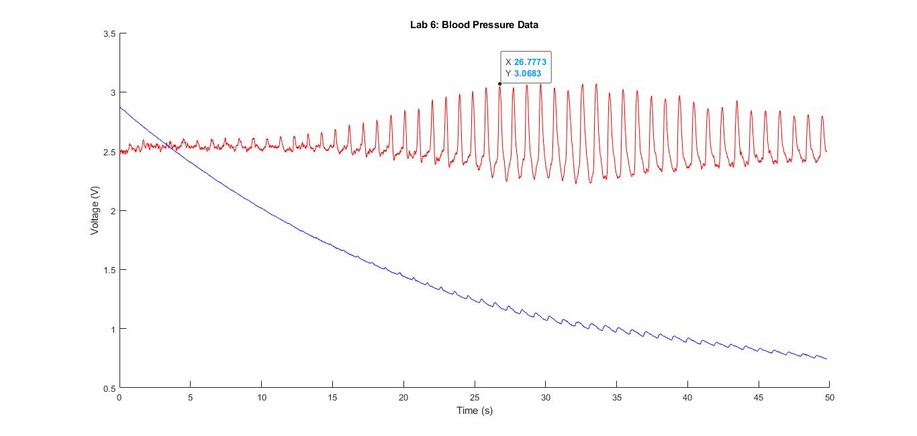

This is the unprocessed data recorded on the scope tool of the analog discovery. It shows the filtered heartbeat as well as the overall pressure signal. Next, the pressure signal must be converted into units of pressure, such as mmHg, from voltage, using a transfer function. The equation of the transfer function of the MXP5050DP Pressure Sensor is written as follows in their datasheet, for a 5V dc input:

Transfer Function: Vout = 0.09*P[kPa]+0.2

Converting to solve for Pressure:

P[kPa] = (Vout – 0.2) / 0.09

Since 101.325 kPa = 760 mmHg, converting from units of kPa into mmHg gives us:

P[mmHg] = (Vout – 0.2) / 0.09 * 760 / 101.325 = (Vout – 0.2) * 84.34

Plugging in Vout and graphing the corresponding output Pressure gives the following graph:

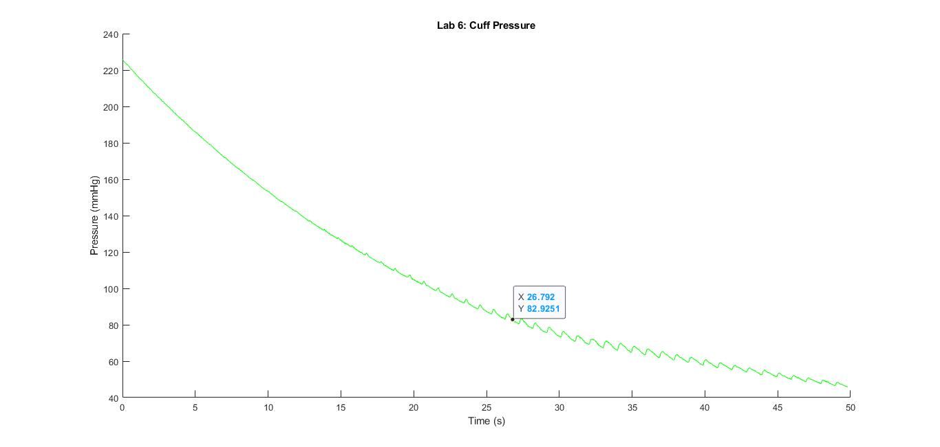

Looking up the maximum spike in the filtered heartbeat above, occurring at x = 26.8 seconds, the corresponding pressure of the cuff at this time is approximately 83 mmHg. This is reasonable and well within the normal range, considered to be 70 - 100 mmHg.

**Bode Plot**

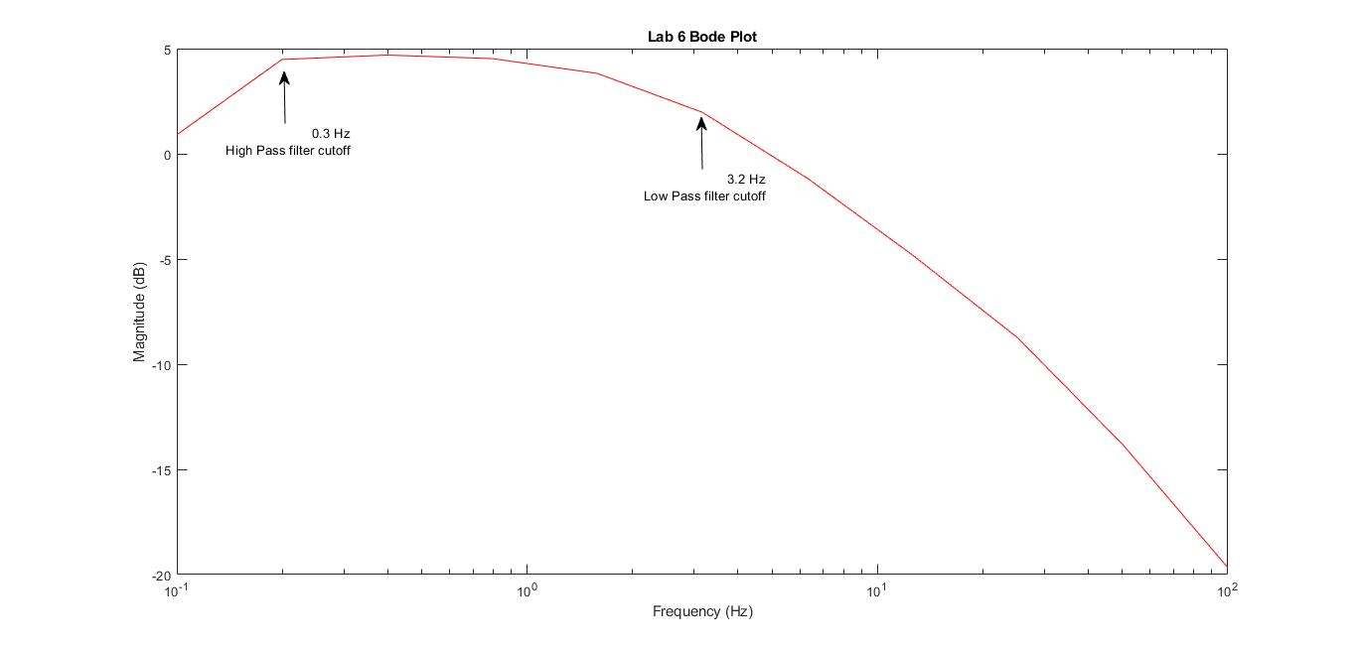

On this graph, magnitude is calculated as -20log(Vout/Vin) and Frequency is defined as cycles/second, producing both the output and the input on a logarithmic scale.

The high and low pass cutoffs are labelled on the graph. In looking at this graph, I can see that the magnitude collected for the frequency cutoff values is generally are located at or near a transition in slope, which is a good sign This shows that the bandpass filter is working, because it is dampening signals below the lower cutoff and above the higher cutoff more than in the middle of the range.

Overall, the shape of the bandpass filter is evident in the graph above. Also, from the blood pressure data in the previous section, I have concluded that it is at least somewhat functional, performing its’ purpose of identifying heartbeats and filtering out the cuff pressure interference.